Question 1: Memory Layout Visualization
Draw the memory layout for the following data structures storing the integers [10, 20, 30]:
- An array list with capacity 5
- A singly linked list
- A doubly linked list
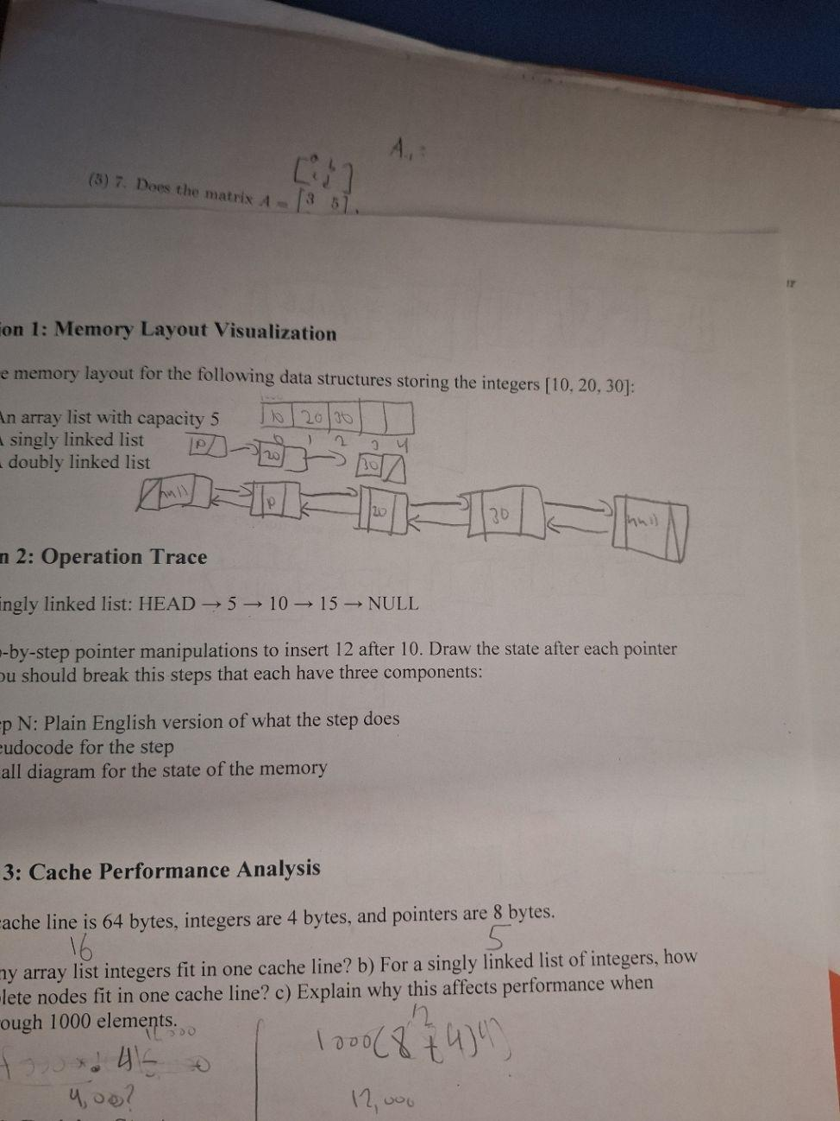
Question 2: Operation Trace
Given a singly linked list: HEAD → 5 → 10 → 15 → NULL
Show step-by-step pointer manipulations to insert 12 after 10. Draw the state after each pointer update. You should break this steps that each have three components:
- Step N: Plain English version of what the step does
- Pseudocode for the step
- Small diagram for the state of the memory
void insert(SinglyNode* head, SinglyNode* target, int d) {
//d = 12
Make the current node 15
while (curr->next != target) {
curr = curr->next;
}
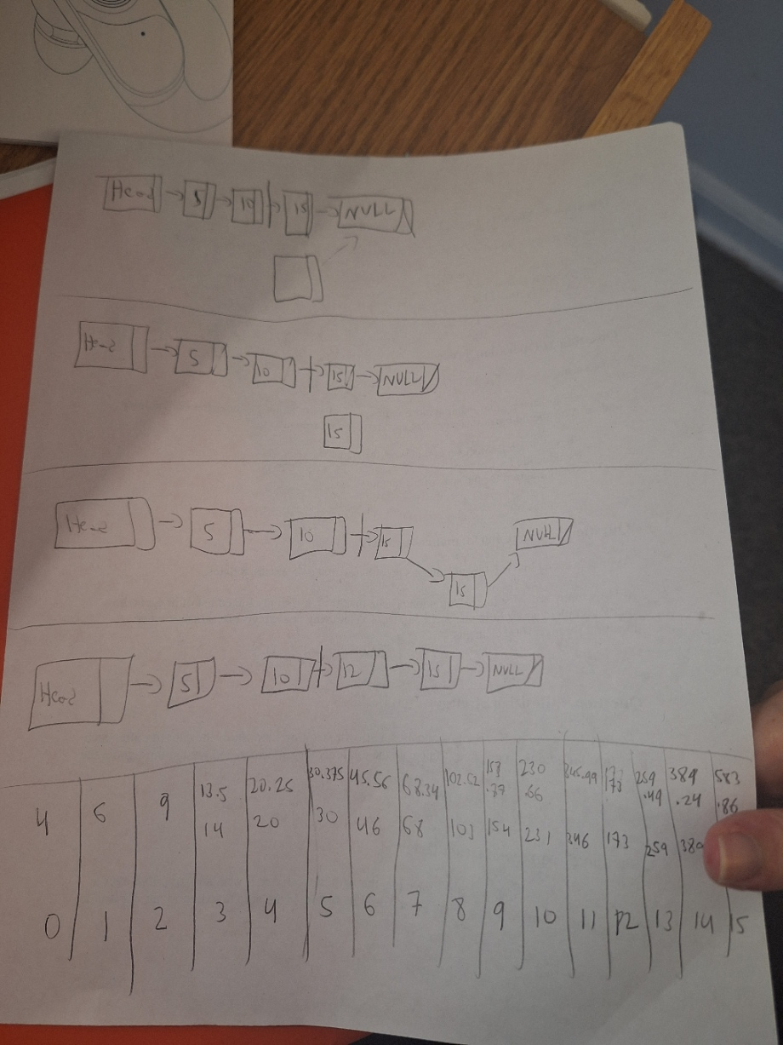
Create a new node that points to the next node
SinglyNode* node = new Node();

Copy the value 15 into the new node
node->data = curr->data;

Have the new node point to the next node
node->next = curr->next;

Copy 12 into the current node
curr->data = d;

Question 3: Cache Performance Analysis
Assume a cache line is 64 bytes, integers are 4 bytes, and pointers are 8 bytes.
- How many array list integers fit in one cache line? 16 ints
- For a singly linked list of integers, how many complete nodes fit in one cache line? 5 nodes
- Explain why this affects performance when iterating through 1000 elements. Because a linked list uses extra bytes for the pointers, it could take longer to load than an array list.
Question 4: Resizing Strategy
An array list starts with capacity 4 and uses a growth factor of 1.5x. Show the capacity after each insertion for adding 15 elements. Calculate the total memory allocated and wasted throughout the process.
Rows from top to bottom: elements, memory allocated, memory wasted
Memory of tenth rounded up
0 | 1 | 2 | 3 | 4 | 5 | 6 | 7 | 8 | 9 | 10 | 11 | 12 | 13 | 14 | 15
4 | 6 | 9 | 13.5 | 20.2 | 30.4 | 45.6 | 68.3 | 102.5 | 153.8 | 230.7 | 346 | 519 | 778.5 | 1167.7 | 1751.5
16 | 20 | 24 | 28 | 32 | 36 | 40 | 44 | 48 | 52 | 56 | 60 | 64 | 68 | 72 | 78

Question 5: Implementation/Usage
Provide an example of two applications: one that would work better with an Array List over a Linked List, and one where a Linked List would be better. Make sure to explain your reasoning.
An Array List would work better on things that have an exact amount or limit, like digits in a phone number.
A Linked List would work better if there was an unknown limit, or things that can be continuously added, like a growing population.

